Procurement and Inventory Analysis using AI Agent

Monika Ścipień
04-2026
Business Scenario:
A company manages inventory across multiple materials and suppliers.
Due to limited visibility, there is a risk of stock shortages and inefficient purchasing decisions.
The objective is to use AI to analyze procurement and inventory data and provide recommendations for stock optimization and supplier management.
Approach:
1. Prepared sample procurement and inventory dataset
2. Used AI (ChatGPT) to analyze the data
3. Designed prompts simulating a procurement analyst role
4. Enhanced prompts with SAP S/4HANA context
5. Compared outputs and insights

- We received the following Excel file with material data:
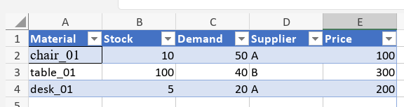
- Go to chat gpt and enter the prompt.
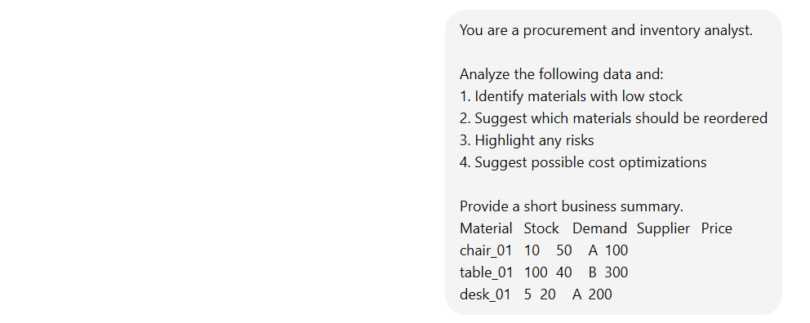
- Check the output:
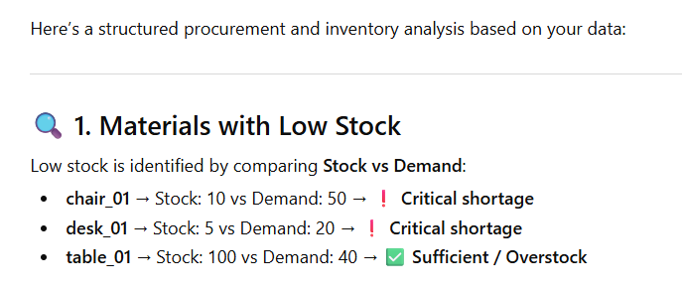
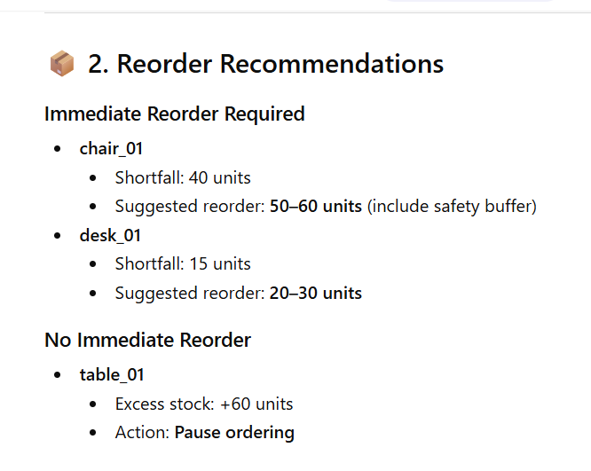
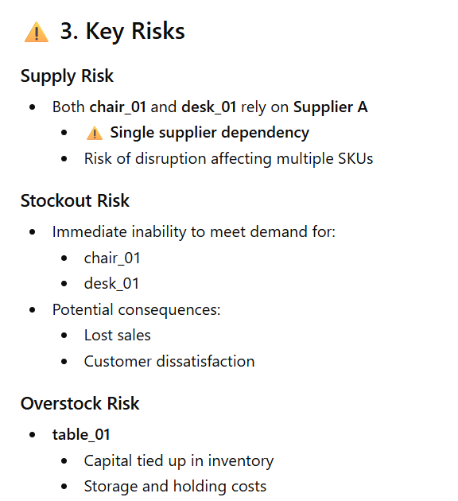
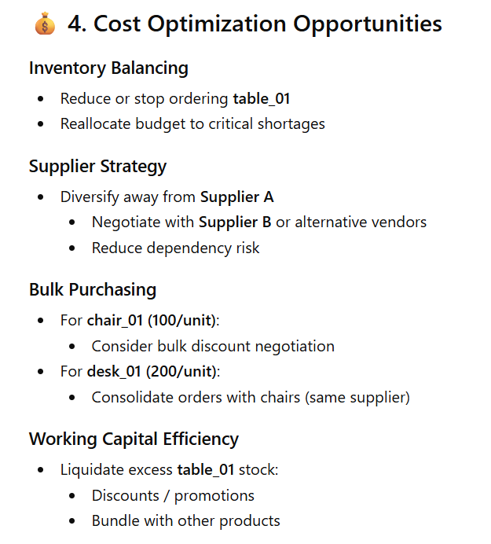
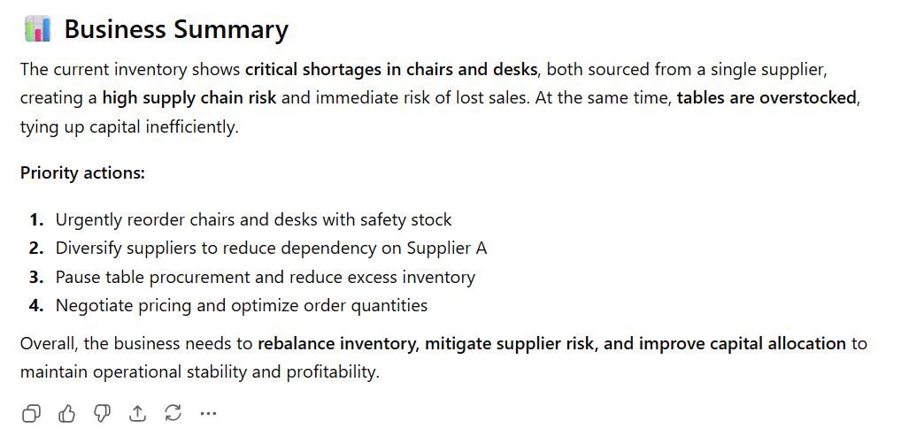
- Add additional context and check the output:
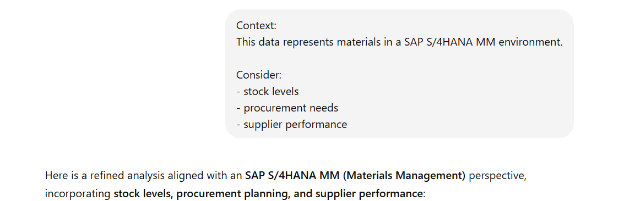
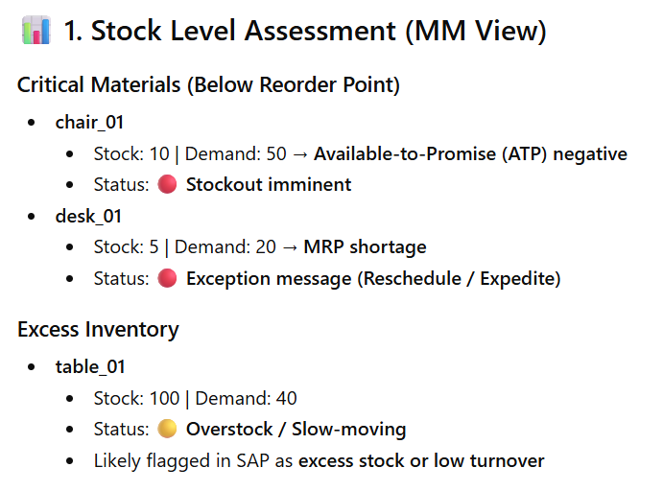
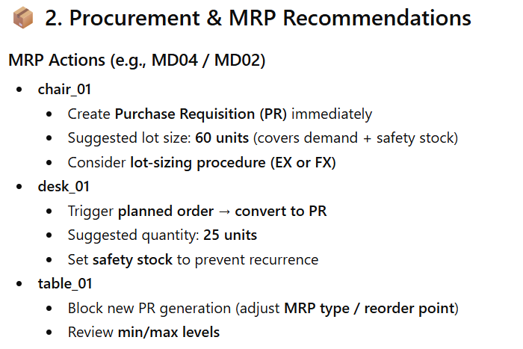
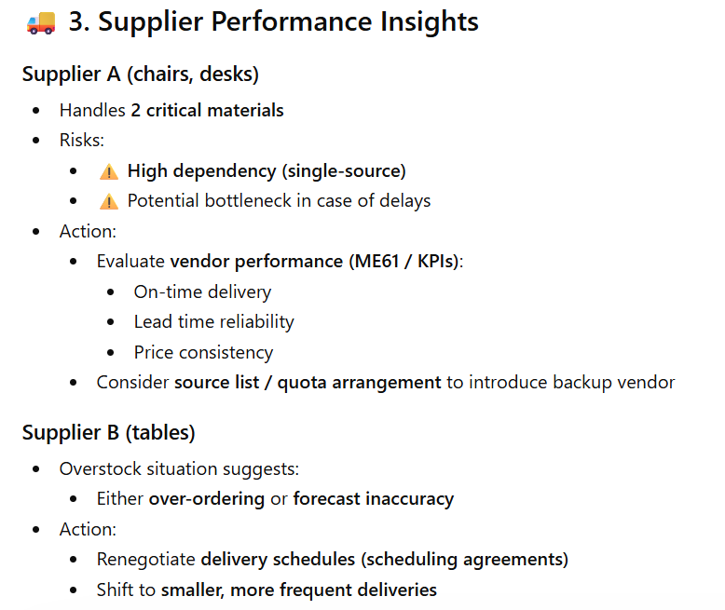
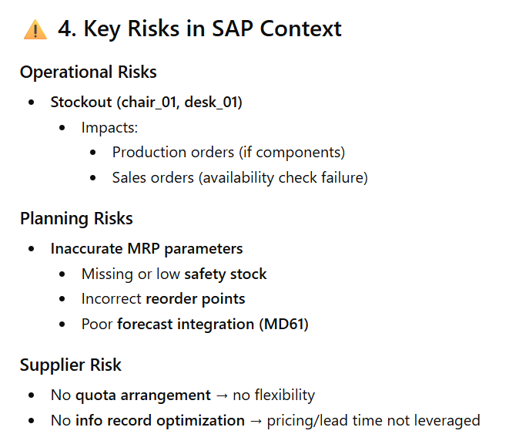
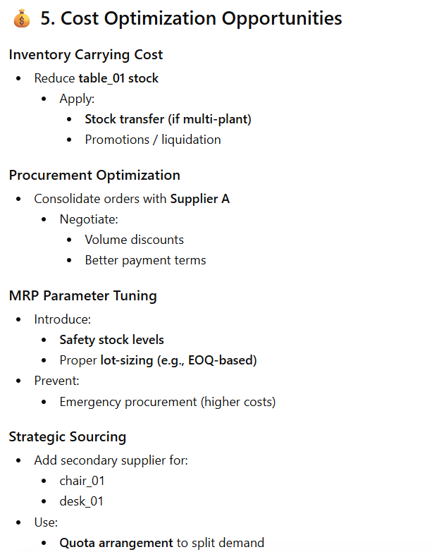
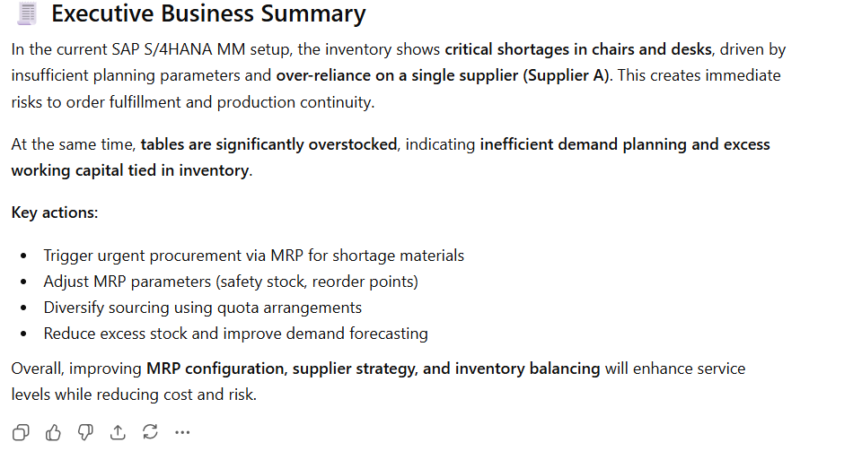
Conclusion
This project demonstrates how AI can support procurement and inventory decision-making by providing fast and actionable insights.
It highlights the potential of combining SAP knowledge with AI tools to improve business processes.

